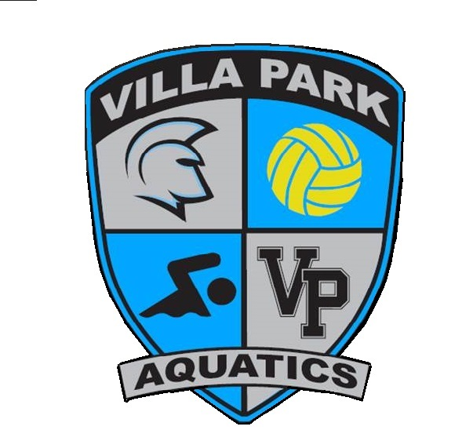
Tuesday, May 30, 2017
6:00-9:00 pm
Villa Park High School
Performing Arts Center
Buffet dinner will be served.
Appropriate banquet attire requested.
(male athletes in shirt and tie)

Please RSVP by May 20, 2017
E-mail: vpaquatics@outlook.com
Athlete Name:
Athlete Name:
No. of Athlete/s attending (gratis):
Did you purchase a Sparty Package at registration which included two banquet tickets)? Y / N
Number of additional guests @ $25 per person: Total enclosed: $__________
Make your check payable to “VPHS-AEP”
Checks can be given to, mailed or dropped-off to:
Amy Rabun
9162 Smoketree Lane
Villa Park, CA 92861

